PTController & PPTControllerHost Description

PPTController & PPTControllerHost are two apps which can help you control your PPT through your Phone.

**PPTControllerHost** is a **Win form** app which install on your computer side, which one you are going to have presentation. It will listen the control commands from **PPTController**to perform the followingoperations to your PPT, start your PPT, switch your PPT between "Fullscreen mode" with "Preview mode", navigate in your PPT.

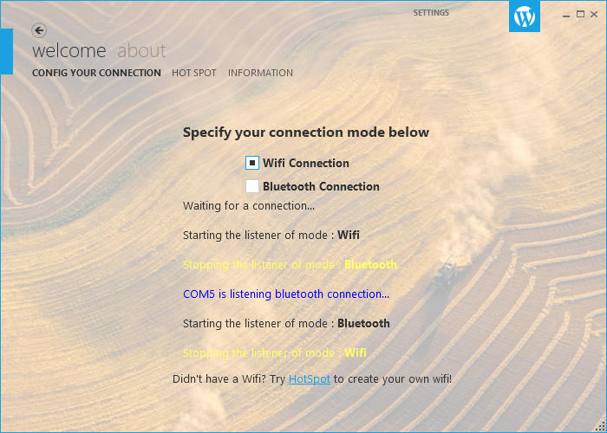

**PPTController** is a **Windows Phone** app (currently only support windows phone platform) which installed your phone side. Send the control commands to **PPTControllerHost** after a connection was established between them.

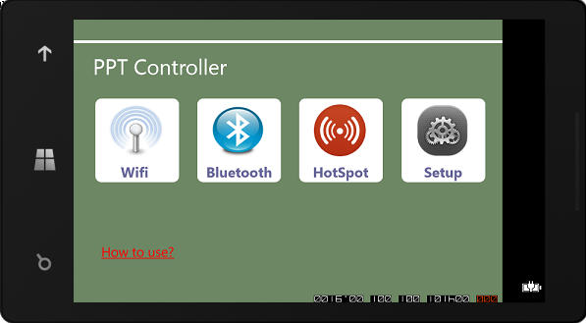

**Download & Installation**

**Click here to download both PPTController &PPTControllerHost package. Before the installation of PPTControllerHost. Please make sure your computer had installed** [**.Net Framework 4.5**](http://www.microsoft.com/zh-cn/download/details.aspx?id=30653)

**How to config PPTController & PPTControllerHost?**

**See**[**PPTController& PPTControllerHost Functional description**](http://hi.baidu.com/wangpeng_zheng/item/b69158c0e1d40e3199b498fd)**to learn it step by step.**

**Common Problems?**

**See this page to if you meet similar problems.Strong recommend to read this page to get known of this app.**